**Phase 1: Requirement Engineering**

**Earthquake Alert Service**

Jose Enriquez, Parker Hague, Robby Hallock, Cody Ray, Jeff Roden

**Requirement Gathering**

**Empathy Map:**

See:

Earthquake radius

Map of earthquake locations

Text message

Table of information about each earthquake

Input boxes for search criteria

Think and Feel:

Phone vibration

Feel an earthquake

Feel worried about close proximity earthquakes

Feel happy to have a useful earthquake notification tool

Think about search parameters needed to make search

Hear:

Phone notification

Text to speech

App earthquake notification sounds

Sounds of mouse clicks and keyboard presses

Say and Do:

Input parameters to search for earthquakes

Think about relevant search criteria

Pull out phone to receive earthquake notifications

Click submission button to receive earthquake results

Pains:

Internet connection not working

App server not responding to clients

No earthquakes that fit the search criteria

Not understanding how to work the app

Gains:

Information on earthquakes

Reassurance knowing about close proximity earthquakes

Ability to get earthquakes any time of the day

Easier to get relevant earthquake information than watching local news

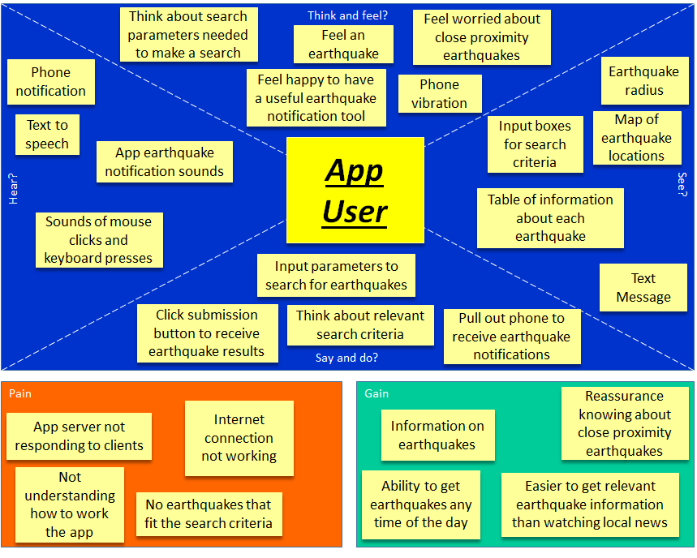

**Requirements**

**Functional**:

* Users create an account and have a profile through which they manage the service.
* Users can choose to receive notifications via text, email or both
* Can view notification history through web app
* Notifications display magnitude, distance from nearest city, and the time an earthquake occurs
* Notifications show link to display earthquake location on a mapping service
* Can enter a minimum cut off for earthquake magnitude
* Service can support multiple areas of interest for Notifications
* Can elect to receive daily or weekly report summaries of earthquake activity
* Home screen of the web app displays recent earthquakes throughout the world
* Sleep function to block notifications for a time period
* Verification email sent to user to confirm account
* User can halt text notifications by replying STOP
* Areas of Interest(AOI) specified by entering latitude / longitude or city name
* Areas of interest are bounded by a radius from lat/long or given city, specified in miles

**Nonfunctional:**

* Users notified within 3 minutes of data becoming available through the USGS
  + Metric: Speed - measure in minutes
* Ability to support at least 1000 users throughout United States/Northern America
  + Metric: Size - measured by users
* Easily Manageable backend so it doesn't cost much to run the service
  + Metric: Size - less than $1000 to operate for the first year.
* A user can learn how to use and manage the service within 5 minutes
  + Metric: Ease of Use - measured in minutes
* Pulls real time earthquake data from the USGS API
  + Metric: Reliability - data is widely available and from a trusted source
* User accounts are distinguished by email address, must be unique in the system and verified.
  + Metric: Security - prevents abuse of system
* App will be developed through the use of CSS, HTML, and JavaScript
  + Metric: Ease of Use - defining languages to be used in project scope
* Twilio API will be used for pushing text messages
  + Metric: Compatibility - app will be native to API
* Google Maps will be used for mapping service to display earthquake locations
  + Metric: Compatibility - app will be native to API

**Requirement Specification**

We began our requirement process by first creating an empathy map to get a broad picture of what the app would be like. This was useful in helping us gain a feel for what a user would expect of our service. To help formulate more ideas of functions we would like to implement, we also created an Insight Matrix. We then moved from these higher level views, into brainstorming functional requirements for the app service. In all we came up with 14 functional requirements to achieve within our app. All of the requirements center around one primary function, which is to push text message notifications to a user shortly after an earthquake occurs. We then decided on non-functional requirements, to further outline how we would implement and support our app. Listed below are more detailed requirement specifications for the app:

* Users create an account and have a profile through which they manage the service. Once a user signs up for the service, they will be presented with a user profile page. From this profile they can add, edit, or delete areas of interest for notifications and control other settings for the app.
* Users can choose to receive notifications via text, email or both. On their user profile page, a user can choose between being notified about earthquakes through the various methods. The options will be chosen by checkboxes and a save button.
* Can view notification history through the web app. The user can select a time range for which they can see earthquake information. As the user scrolls up, the app loads earthquake information from further back in history. The user can also search through the history for earthquakes at a particular magnitude or location.
* Notifications display magnitude, distance from nearest city, and the time an earthquake occurs. Text notifications will follow a standard template of listing the magnitude of the earthquake followed by a time. This will be followed by a listing in miles how far away the epicenter was from the nearest city and a link for a pin drop that shows the location on google maps
* We wanted users to be able to customize the types of earthquakes they were notified about so we allowed users to enter a minimum cut off for earthquake magnitude. If a user is selecting a seismically active area, there could be dozens of smaller earthquakes that happen throughout the day, so implementing a minimum size threshold will reduce the amount of notifications received.
* Multiple areas of interest will let users select different areas throughout the world. For example, this could let a user receive updates for earthquake activity in the area they live in, as well as a different city that perhaps their family lives in.
* Besides real-time notifications, the service can also provide daily or weekly activity reports. Detailing the amount of earthquakes that have occurred and their relative magnitudes.
* Home screen of the web app displays recent earthquakes throughout the world, this information will be displayed when a user first visits the site and can highlight some of the more seismically active areas in the world.
* Sleep function to block notifications for a time period, users can input how many days or weeks they would like to not receive any notifications. After that time period the notifications would resume with what the user has set.
* Verification emails are sent to a user to confirm their account. This is to prevent multiple accounts from being created and limit abuse of the system. When a user first signs up for the service, they will receive a confirmation email that they will use to verify their account by clicking a verification link.
* User can halt text notifications by replying STOP. They will receive a text letting them know that they will no longer be receiving texts and how they can re-enable it. The user can resume text notifications by replying RESUME.
* Areas of interest can be specified by the user when they enter latitude and longitude, or city name. The user will be able to see a map of location, as well as a toggleable dot on the exact coordinates. The user will also be able to toggle longitude and latitude line visuals. Finally the user can change the color and transparency of the lines and the dot.
* Areas of interest are bounded by a radius from latitude, longitude, or given city, specified in miles. The user will be able to see a toggleable circle on the map showing the area of interest. The user can change the color and transparency of the circle.

**Insight Matrix**

| Features/ Sources | Amazon | Doctor’s Office | Weather Service | Fandango | Facebook |
| --- | --- | --- | --- | --- | --- |
| Input Search Functionality | X |  | X | X | X |
| Uses API | X |  | X |  | X |
| Text Message  Alerts |  | X | X |  | X |
| User Friendly Web UI | X |  | X | X |  |
| Global area | X |  | X |  | X |
| Limits Search Location |  |  | X | X | X |
| Has Desktop & Mobile Version | X |  |  | X | X |
| User Profiles |  | X |  |  | X |